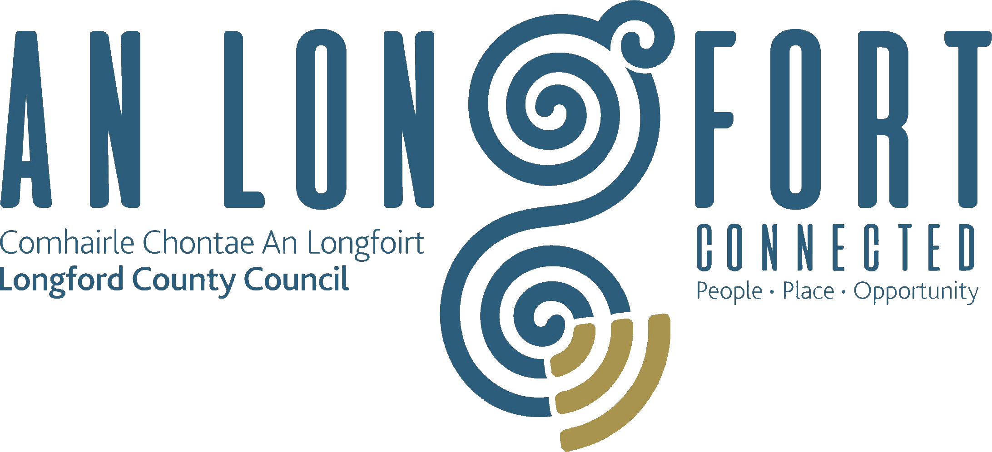

Minutes of January 2020 Meeting of Longford County Council
held in the Council Chamber, Aras an Chontae, Great Water Street, Longford on
Wednesday, 15th January 2020 at 3.00 p.m.

____________________________________________________________________

PRESIDING: Councillor Gerard Farrell, Leas-Cathaoirleach.

MEMBERS PRESENT: Councillors – Paraic Brady, John Browne, Seamus Butler, Mick Cahill, Mark Casey, Joe Flaherty, Gerard Hagan,
Martin Monaghan, Colm Murray, Garry Murtagh,
Turlough McGovern, Peggy Nolan, Pat O’Toole, P.J. Reilly, Paul Ross and Gerry Warnock.

IN ATTENDANCE: Mr. Paddy Mahon, Chief Executive.
Mr. John McKeon, Head of Finance/Director of Services.
Mr. John Brannigan, Director of Services.
Ms. Barbara Heslin, Director of Services.

APOLOGY: Councillor Micheál Carrigy.

MEETINGS
ADMINISTRATOR: Anne Lee.

SONG FOR LONGFORD.

A video showing the “Song for Longford” was shown at the beginning of the meeting.

The video of Padraic Colum’s famous song “She moved through the Fair” was commissioned by Creative Ireland Longford and all the artists and the production team were from Longford.

The members complimented the production which they all agreed highlights the fantastic talent in County Longford.

Councillor P. Nolan suggested that the video be played at all events hosted by the County Council.

ADOPTION OF MINUTES.

On the proposal of Councillor S. Butler seconded by Councillor P. Brady, the Minutes of Finance Committee Meeting of Longford County Council held on the 15th November 2019, as circulated, were confirmed and adopted.

On the proposal of Councillor S. Butler seconded by Councillor C. Murray, the Minutes of Budget Meeting of Longford County Council held on the 25th November 2019, as circulated, were confirmed and adopted.

On the proposal of Councillor S. Butler seconded by Councillor G. Warnock, the Minutes of Meeting of Longford County Council held on the 11th December 2019, as circulated, were confirmed and adopted.

MATTERS ARISING FROM MINUTES.

None

DECLARATION OF INTEREST BY MEMBERS.

None

MONTHLY MANAGEMENT REPORT.

The Monthly Management Report, as circulated, was noted.

MINUTES OF CORPORATE POLICY GROUP MEETING HELD ON THE
13TH NOVEMBER 2019 - circulated

The adopted Minutes of Corporate Policy Group Meeting held on the
13th November 2019 were noted.

PREMIER LAKELANDS FOOD HUB

P. Mahon briefed the members on the recent announcement regarding funding towards the development of a food hub in Lanesboro from the Regional Enterprise Development Fund (REDF).

Paddy stated that the funding was secured following a very competitive application process and demonstrated the importance of collaboration between the local community, Bord na Móna and Longford County Council.

This project will support the transition of Bord na Móna and its workforce, support further development and commercialisation of new products and offer opportunities for redeployment for many of its workers. The project will also assist in the just transition agenda, support the Government’s climate action plan and deliver on Longford County Council’s commitment to supporting local communities in sustainable economic development.

Barbara Heslin stated that possible timelines for the project were discussed at a meeting held with Bord na Mona on the 14th January. She also confirmed that Bord na Mona’s commitment to the project will be required to ensure the successful delivery of the project. Additional funding will also be required and submissions will be made by the Council for funding from the Just Transition Fund.

CORPORATE, COMMUNITY AND ENTERPRISE.

Strategic Policy Committee Scheme 2019 – 2024.
B. Heslin provided an update regarding the Sectoral Representatives on the four Strategic Policy Committees and stated that there are a number of positions still to be filled. Barbara confirmed that the inaugural SPC meetings will commence this month.
On the proposal of Councillor S. Butler seconded by Councillor C. Murray, it was agreed to adopt the updated Strategic Policy Scheme, as detailed by Barbara. The Sectoral Representatives as outlined in the Scheme were approved.

Draft County Longford Heritage Plan 2019 – 2024 – circulated.
On the proposal of Councillor S. Butler seconded by Councillor P. Nolan, it was unanimously agreed to adopt the County Longford Heritage Plan 2019 – 2024, as circulated.

Barbara and the members complimented Mairead Ni Chonghaile for her excellent work in preparing the new Heritage Plan.

Political Donations.

Political Donations- Local Elections (Disclosure of Donations and Expenditure ) Act
1999, as amended - Members of Local Authorities.

It was noted that completed Annual Donation Statements should be returned to the
Meetings Administrator before 31st January 2020.

FINANCE & REGENERATION.
NOAC Performance Indicators Report 2018 – circulated.
J. McKeon gave a comprehensive presentation on the NOAC 2018 Performance Indicators Report and replied to queries raised.

Local Government Act 2001 - Annual Ethics Declaration.

J. McKeon informed the members that the closing date for return of Annual Ethics Declaration Forms is 29th February 2020.

STRATEGIC INFRASTRUCTURE AND CLIMATE CHANGE.

Planning Applications.

The lists of Planning Applications received since the last meeting of the Council were noted.

Notices of Motions.

New Build Affordable Housing Scheme

The following Notice of Motion was proposed by Councillor G. Warnock and seconded by Councillor C. Murray –

“I am seeking the support of the Members for approval in principal for a ‘New Build Affordable Housing Scheme’ that I hope can eventually be used by Longford County Council as an additional tool to provide affordable housing options for qualifying local households. If supported by the Members, I plan on submitting this scheme directly to the Minister for his observations, and perhaps seek his approval and financial support for a pilot under the Rebuilding Ireland Programme.”
Councillor Warnock received the full support of the members present.
J. Brannigan informed the members that the executive are awaiting the outcome of a recent meeting held between officials from the Department of Housing, Planning and Local Government and Department of Public Expenditure and Reform in December. The current affordable housing scheme contains a number of criteria including that the maximum difference between the build and current market value of a house in the County is 10%, this currently leaves the scheme unworkable in the County.

GENERAL

Notices of Motions.

Speech and Language Therapists.

The following Notice of Motion which was proposed by Councillor P. Nolan, on behalf of Councillor M. Carrigy and seconded by Councillor P. Brady was unanimously agreed –

“I am calling on the Department of Education to employ Occupational and Speech and Language therapists in each county to cover all schools. This would allow for Therapists to see children with needs in their learning environment which would allow them to best advise teachers on how to create a positive learning environment for children with additional needs.”

Dental Healthcare Checks.
The following Notice of Motion which was proposed by Councillor P. Nolan, on behalf of Councillor M. Carrigy, and seconded by Councillor P. Brady was unanimously agreed –

“I call on the Minister for Health to consider an extension of the free dental healthcare checks to children after they leave primary school.”

Commemoration.

The following Notice of Motion was proposed by Councillor M. Monaghan and seconded by J. Flaherty –

“That we as a Council, and with support from my fellow colleagues, recommend that we do not support the commemorations for the RIC . This is something that our ancestors would never forgive us for showing support for a force that terrified our people in their fight for freedom.”

The members discussed the Motion in detail.
B. Heslin stated that the Longford County Council Creative Ireland Culture Team will consider and recommend appropriate commemorations in County Longford.

TRAINING.

Report from Corporate Policy Group was noted.

GENERAL ELECTION – SUPPLEMENTARY REGISTER OF ELECTORS.

Barbara provided an update to the Elected Members on eligibility to vote at the General Election and outlined the following important closing dates –
- Supplement to Register of Electors – Wednesday, 22nd January
- Supplement to the Postal Voters and Special Voters Lists – Thursday, 16th January.

Late applications cannot be processed until after Polling Day.

Barbara also outlined the public awareness campaign planned by the Council and urged people to check that they are registered to vote. She asked for the Councillors support in getting the message out to the Electorate.

Barbara also confirmed that Bridin Concannon is the Returning Officer for the Longford Westmeath constituency.

This concluded the business of the meeting.
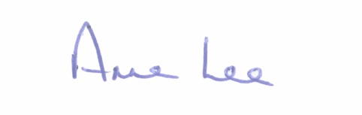

Signed: _______________
Anne Lee,
Meetings Administrator.

Confirmed and adopted at Meeting of Longford County Council held on the
11th March 2020.

Signed: _______________
Cathaoirleach.

